Corporate Profile-Tairak Sports

Name :- Tairak Sports Lvt. Ltd.

Name of Director :- Sucheta Singh, M.Sc (Chemistry)

Name of Coordinator:-Mr. Satish Choudhary, Diploma In Swimming

PAN No. AAGCT2349Q

Contact details +91 9717 333 453
+91 9968 000 218

The Background:-

Tairak Sports is a firm based out of Noida. Our motto is to develop Swimmers of international fame. Of course for the sake of operations & compliances a firm has been established, but our focus continue to be on developing talent rather than making money only. Tairak Sports was established in 2008 with sole aim of developing swimmers of international fame. Our core objective is to lay a strong foundation among children which will help them take responsibility of their fitness and health, and remain healthy and active not only during childhood but throughout their lives.

Tairak Sport Pvt. Ltd. is a company with Mr.Prashant Kumar & Ms.Sucheta Singh as directors.
The name of our company was chosen to signify the importance of swimming as sports and as an essential life skill. It goes a long way if swimming is pursued both at professional & personal (health) front.

The Location:-
The NCR region was chosen to establish this company because of the huge population residing in the area; Noida becomes more important as it is heavily populated and having no infrastructure for the development & promotion of sports. With rapid urbanization it becomes all the more important to harness the huge pool of talent in and around Noida.

The Beginning:-

It all started with a small incident in Faridabad when a group of students who were looking for a decent swimming pool to prepare for an upcoming event/competitions. This search led us to Aravali International School, Faridabad. The site visit bared the grim face of sports facilities; the pool was in shambles, dirty untreated water, unclean pool & changing premise, no coaches(only lifeguards who were there only as a necessity); naturally no one was keen to pursue swimming either for pleasure or for competitions. We immediately spoke to the management & took over the pool for training our students and develop a talent-pool for the school too. We took over the pool for 5 years on contractual basis and the results were very encouraging. We were able to send 10/15 of our students to national level. The school too benefited in many ways, 1st & foremost the pool became the activity hotspot & 70% of the total strength started taking swimming classes. The school also created history for the 1st time by playing at the national levels with a team of 7 students. This was also a landmark change in the history of Faridabad as the event was one of a kind and happening for the 1st time in its making. Then there was no looking back and we went ahead to create more milestones year after year. Following is a brief snapshot of our success:-
- 2009-12 students played nationals at 2 centers.
- 2010- 40 students played nationals at 4 centers……..
- 2017-26 students played nationals at 6 centers.

CSR:-

Today in the academy we run a free evening class for the underprivileged children; we also give them for free, items like swimming aids, accessories & costume.

Array of Services:-

The company trains the aspiring swimmers on the following:-
Swimming strokes & skills.
Triathlons & quathalon.
Synchronized swimming.
Ironman,
Land drills & strength trainings
Aerobics
Yoga & meditation.

In the coming days we aspire to be the sought after academy for creating & nurturing talents of international repute, in the reach of common man. We wish to become the “Best academy for the common man/woman in the NCR”.

The supporters:-
The academy is supported by the following eminent personnel who have achieved unbound excellence in different walks of life:-
- Mr. Bhanu Sachdeva- Arjuna awardee.
- Mr. Khzan Tokas Arjuna Awardee.
- Mr. Satish Suri-Coach of Indian swimming team.
- Mr. Satish Chaudhary( Railways) -Coach-Delhi Swimming Association, & Jt. Secretary District Swimming Association, Noida

Other Activities:-
Consultancy.
Construction & up gradation & renovation of the existing infrastructure.
Installation of plant & heating systems.
Conversion to All Weather Pool.
Supply of manpower/chemical/equipment etc.
Contractual operations.
Periodic maintenances etc.
List of Clients/Academy Centers:-
Sl.No. | Centers in the Past | Current Centers & in the Offing
1. | Aravali International School, Faridabad | G.D Goenka, Rudrapur.
2. | Kothari International School, Noida Sector-50 | G.D Goenka, Rajnagar.
3. | Billabong School,Sector-34,Noida | YMCA, Greater Noida. Swimming Academy
4. | Vivek Vihar Society, Sector-82, Noida | BGN swimming academy, Muniraka, Delhi
5. | Kendriya Vidyalaya, Sector 24, Noida. | Sierra School, Sector-62,noida
6. | Gyanshree, Sector 127, Noida. | Prometheus School , Noida
7. | Railway Officers Club, New Delhi | Dynasty Int. School, Faridabad
8. | Bal Bharti School, Rajender Nagar, New Delhi
9. | Step by Step School,Sector-132,Noida
10. | Dynasty International School, Faridabad.
11. | Venkateswar International School, Dwarka  Delhi.
12. | Bal Bharti School, Noida.

Keeping in view the above mentioned facts of our company, we are looking forward for a very favorable response to serve your prestigious organization. We assure you the best quality guidance, maintainance and upkeep of your swimming pool, which would definitely give pride to the organization.

Web:- tairaksports.in

Email:- info@tairaksports.in
tairaksports@gmail.com
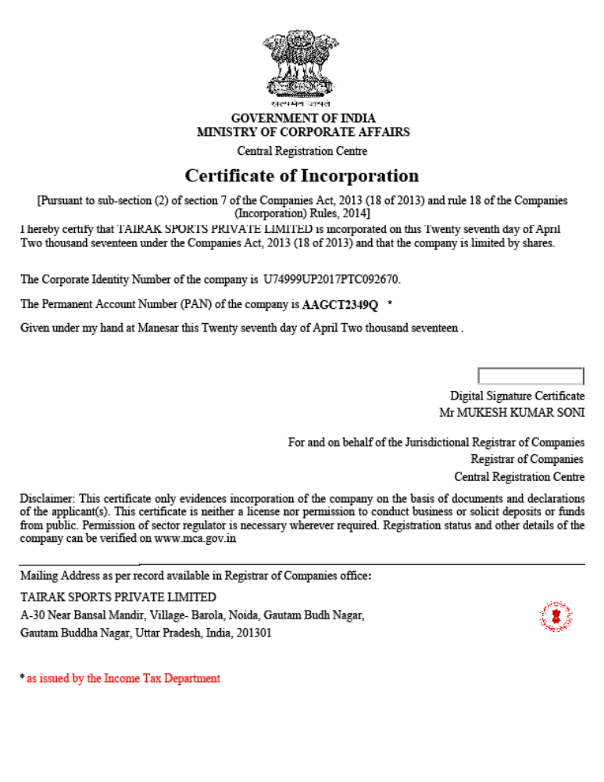

Prometheus Sports Academy, Swimming pool Specification

Main Pool:- Length 50 Meters
Breadth 13.5 Meters
Depth/Deep 03Feet to 04 Feet (0.914Meters to 1.2192 Meters)
Deck Area Non Slippery
Washroom Boys and Girls Separate
Air Quality Ventilated 2 Separate Fresh Air 01 ventilation machine
Filtration Plant 05 Nos with Pump sets
UV’s 2Nos
Water Quality Pools As per Govt Norms and Monthly water testing reports and daily maintain
Lanes 1 to 5
Lane Breadth 2.5 Per Meter
Lane colors 3Yellow and 2Green (follow FINA Norms)
Pool Both side 5 Meters Back stroke Indicators
Pool foul Start rope 15 Meters
Operational time though year (12Months)
Winter Temperature FINA Standard 25C’ to 29C’ (Temperature controlled Heating System)
Heating System As per FINA Standard (2 Heating Pump)
Operation As Per UP Govt Norms safety equipment available
Operation timing Academy 0430AM-09:00AM
04:00PM-08:30PM

Kids Pool Length 10 Meters
Breadth 12 Meters
Depth/Deep 1 Feet and 2 Feet (50%-50%) Separate Dividers in between
Washroom Boys and Girls Separate

Academy Staff
Chief Coach :- Sh. Brij Kant Sharma, Diploma In Swimming, Ex. CO, BSF, 2019
Associated Coach :- Miss Parampal Johal, Diploma in Swimming, Ex- SAI 2020
Volunteer Coach :- Sh. Satish Chaudhary, Diploma in Swimming 2006-07
(Working Railways)
Assistant Coach :- Sh. Rajesh Kumar Certificate in Coaching from Patiala 2022
Life Guard :- Shri Kishan YMCA Certified
:- Sh. Depashish Mazumadar, YMCA Certified
:- Sh. Deepak Kumar YMCA Certified
:- Sh. Siya Ram YMCA Certified
:- Sh. Raj Kishore Plant operator –cum-Life Guard YMCA Certified

